
Learning Assignment Four
Sandra David
CYCP Centennial College - Semester 1 week 10
Mental Health & Wellness 1 (SEC. 401) - CYCP113401_2024W
Amy Pelvin
Due: Sunday, March, 24th, @11:59pm


Jamal Case Study
Jamal is an 8-year-old student in a regular grade 3 classroom. He has a co-occurring learning disorder (reading comprehension difficulties) and attention deficit disorder type two.
Jamal demonstrates behaviours that include the inability to sit during pencil and paper tasks, his failure to follow multiple instructions at one time, difficulty with all tasks where staff are not able to immediately read instructions or explain 1:1 to him, frustration with peers that results in him lashing out with physical aggression, and no established peer group resulting in much difficulty at recess.
He is also influenced by other students' behaviours and has been observed to negatively impact the classroom. These inappropriate social behaviours limit his ability to complete classroom work and cause him to be socially isolated from his classmates.
For example, at recess, Jamal has been found throwing rocks at peers from the playground and blocking playground areas for other children.
The special education classroom teacher feels that Jamal would be an outstanding individual to work with a child and youth worker to improve his behaviour and academic work habits.
Jamal has just started taekwondo and is also interested in collecting Pokémon cards.
After observing Jamal in the classroom (several times), reviewing his school records and psychoeducational testing results, and interviewing the teacher, his parents and Jamal, YOU the CYC, decide that designing a token economy would be an effective intervention.
Part One:
1. Possible goal areas for Jamal:
- Improved classroom behavior
- Increased social skills and peer interaction
- Better academic performance
- Anger management and conflict resolution skills development
- Participation in structured activities during recess
2. Individuals who should be involved in an intervention treatment plan:
- Special education classroom teacher
- Child and youth care practitioner
- School counsellor
- Jamal's parents
- Principal or school administrator
- Peers (for social skills training and support)
3. Jamal's Interests:
- Taekwondo
- Pokémon card collecting
4. Rewards that Jamal could work towards or earn:
Small Prizes
- Treasure box full of Pokémon cards or related merchandise for him to pick through.
Big Prizes
- Choosing a recess game, being the line leader for the whole day, Going to the gym and teaching classmates Taekwondo.
5. Other interventions besides a TES:
  - One-on-one counselling sessions focusing on behaviour management and social skills development
  - Social skills training groups with other students
  - Individualized education plan (IEP) modifications to accommodate learning difficulties
  - Parent Teacher Meeting sessions to learn strategies for managing Jamal's behaviour at home
  - Mediation and conflict resolution sessions with peers
Part Two:
Token Economy System (TES) Chart:
Goal Statement: Jamal will demonstrate improved social skills and behaviour during recess by engaging in positive peer interactions and structured activities for the next two weeks.
| Behavior/Task | Tokens Earned Each Time Task/ Behaviour Happens | Evaluation Criteria
| Engaging in positive interactions with peers | 1 tokens | Peer feedback and observation by staff
| Participating in structured activities | 2 tokens | Attendance and participation record
| Following playground rules and guidelines | 1 tokens | Observation and feedback from staff
| Demonstrating conflict resolution skills | 2 tokens | Resolution of conflicts without aggression
| Completing assigned tasks during the day | 1 token | Task completion is verified by staff

TES Idea: Pokémon Adventure Board
- The TES chart resembles a Pokémon-themed game board with various spaces representing different tasks or behaviours.
- Jamal earns tokens (Poké Ball) for completing tasks or demonstrating positive behaviours during recess.
- He can move his Pokémon character along the board based on the number of tokens earned.
- Jamal can collect Pokémon cards or other rewards related to his interests at certain checkpoints or milestones.
- The evaluation of tasks and behaviours is done by staff observation and peer feedback.
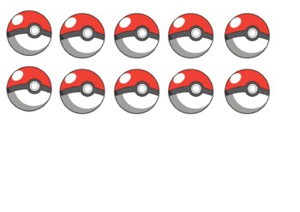

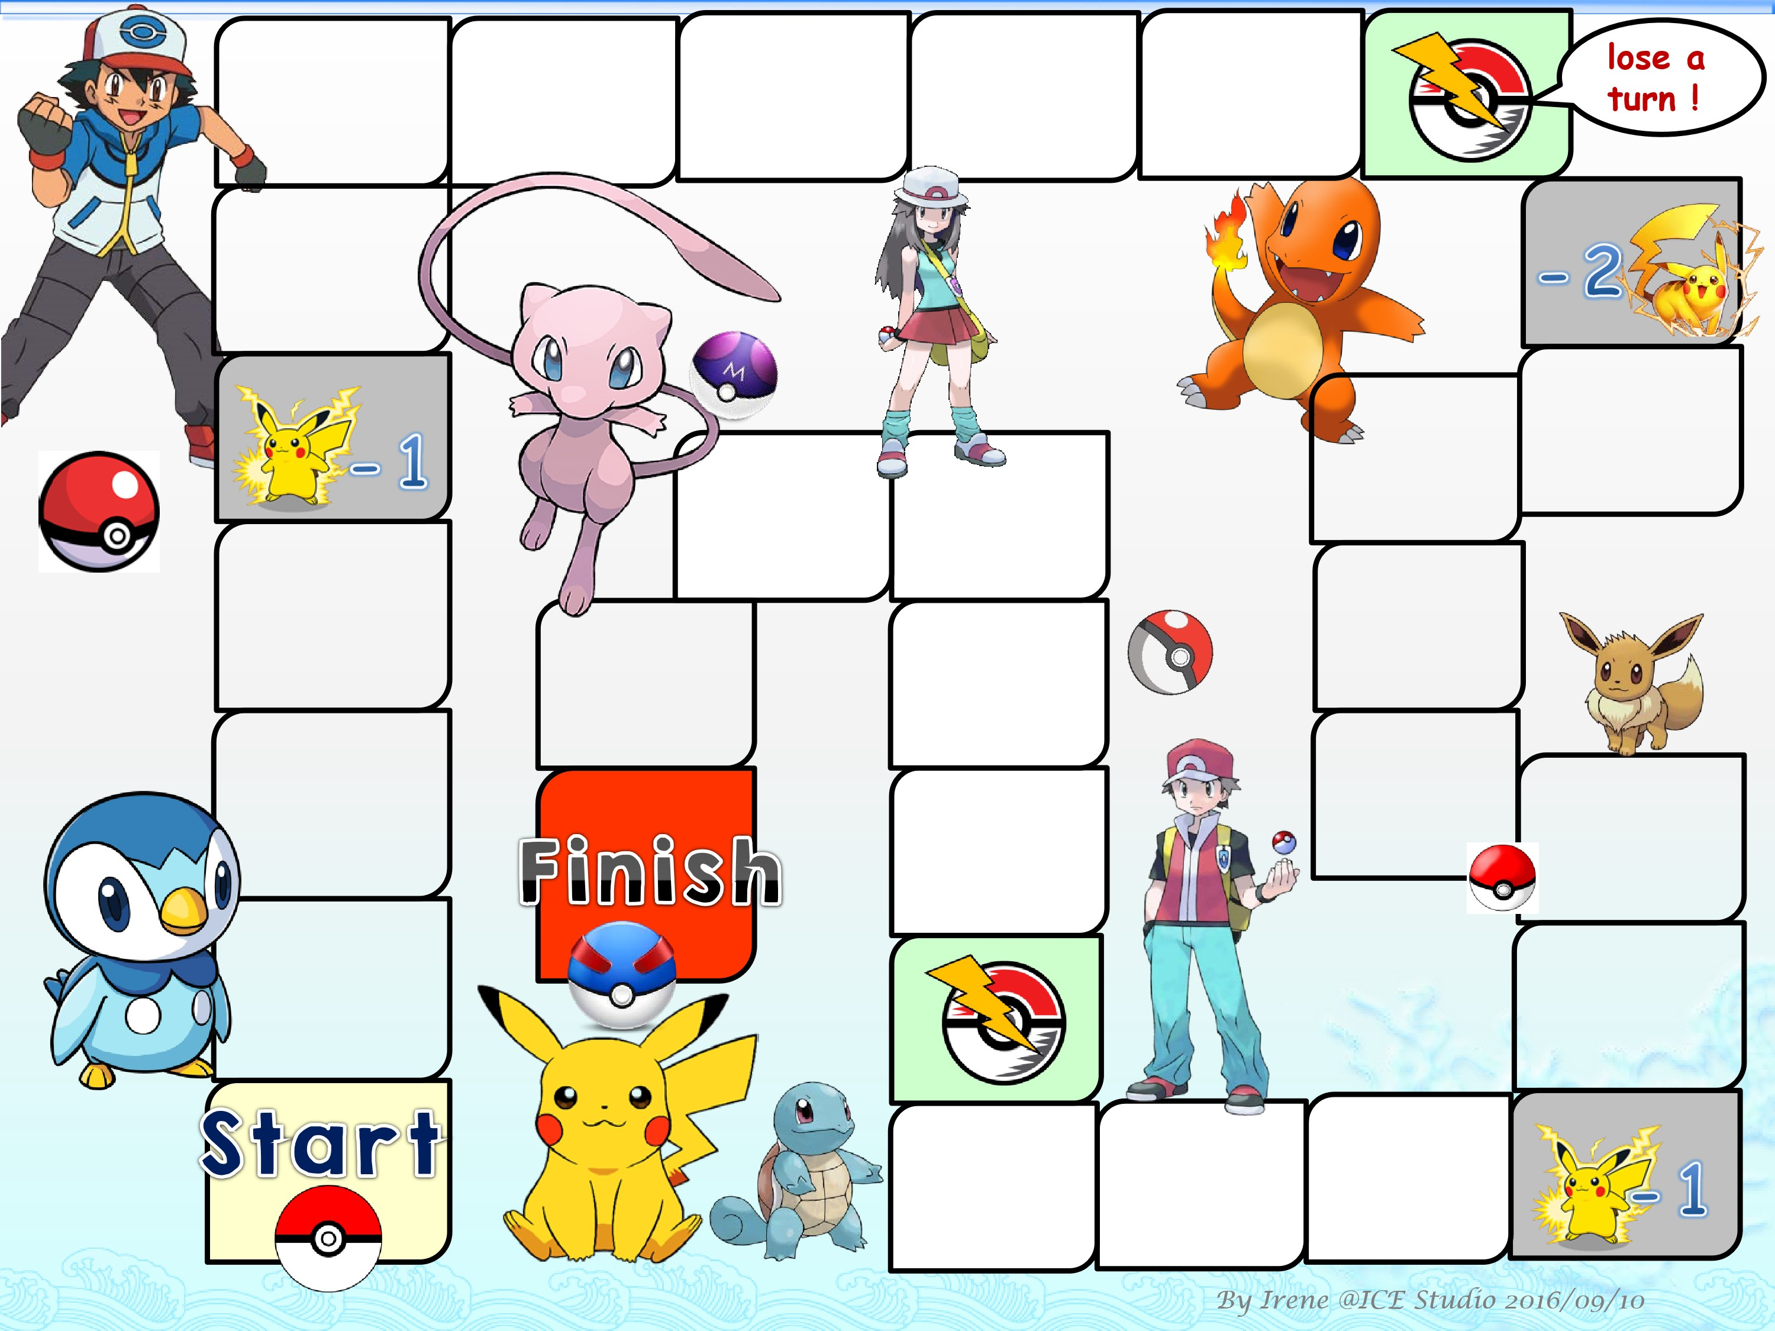
You made it to your big prize! GREAT JOB!
You’re So Close Keep it up!

You Caught one prize
You Caught one prize
You Caught one prize

You’re Half way there!

